CARVION AI
AI-POWERED CAREER DEVELOPMENT PLATFORM
A Project Synopsis

Submitted by
LOHITH M MARATHI
PO2JH24S126004

Master of Computer Applications (MCA)
2025-26
At

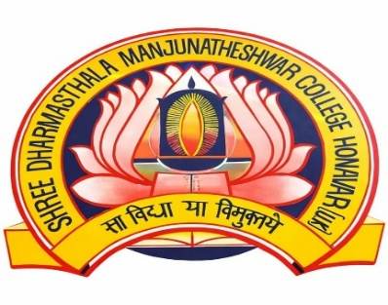

M.P.E Society’s
SHREE DHARMASHTHALA MANJUNATHESHWAR
COLLEGE OF ARTS, SCIENCE AND COMMERCE,
HONNAVAR – 581334
ACCREDITED WITH "A+" GRADE BY NAAC


M.P.E Society’s
SHREE DHARMASHTHALA MANJUNATHESHWAR
COLLEGE OF ARTS, SCIENCE AND COMMERCE, HONNAVAR – 581334
ACCREDITED WITH "A+" GRADE BY NAAC

Proposed Project Title: CARVION AI [AI-Powered Career Development Platform]

Student Details:

Name: LOHITH M MARATHI Exam Seat No.: P02JH24S126004

Branch: COMPUTER APPLICATION Semester: IV SEM

Front End: React.js, Vite, HTML5, CSS3, JavaScript, React Router DOM, and Axios.

Back End: Python, Django, Django REST Framework (DRF), MongoDB, MongoEngine,
Google Gemini API, and Simple JWT.

Facilities/Framework required: Computer/Laptop (Intel Core i5 or above), 8 GB RAM,
256 GB SSD, Windows 10/11, Visual Studio Code, Node.js, Python 3.11, MongoDB, Git, Postman, and a stable Internet connection.

Proposed Project Abstract:

Carvion AI is an AI-powered career development platform designed to help job seekers improve their career readiness through intelligent guidance and personalized recommendations. The system enables users to upload resumes, analyze ATS compatibility, identify skill gaps, and receive suggestions for improvement. It also recommends suitable jobs, learning resources, and personalized career roadmaps based on the user's profile and career goals. The platform includes an AI-based mock interview module that provides feedback to improve interview performance. An AI chatbot is integrated to assist users with career-related queries and platform navigation. The application is developed using React.js for the frontend, Django REST Framework for the backend, MongoDB as the database, and the Google Gemini API for AI-powered analysis. The system also includes an admin module for managing users and monitoring platform activities. Overall, Carvion AI provides an integrated and user-friendly solution that supports resume enhancement, skill development, and career planning in a single platform.

INTRODUCTION
The rapid growth of technology and the increasing competition in the job market have created a need for intelligent and user-friendly career development solutions. Many job seekers face difficulties in preparing professional resumes, identifying the skills required for their desired jobs, finding suitable learning resources, and performing well in interviews. Existing career support platforms usually provide only individual services such as resume creation, job searching, or online learning, making it difficult for users to manage their career development in one place. Carvion AI is a full-stack, AI-powered career development platform designed to assist job seekers in building optimized resumes, discovering personalized career paths, and preparing for job interviews through an integrated suite of intelligent tools. The platform bridges the gap between raw candidate potential and industry readiness by combining modern web technologies with large language model capabilities.
Carvion AI is an AI-powered career development platform developed to help job seekers improve their career readiness through intelligent guidance and personalized recommendations. The system allows users to upload resumes, analyze ATS compatibility, identify skill gaps, receive career guidance, access learning resources, and prepare for interviews using AI. By integrating these features into a single platform, Carvion AI provides a simple and effective solution for career planning.

FIELD OF THE PROJECT
The project belongs to the fields of Web Application Development, Software Engineering, Artificial Intelligence (AI), and Natural Language Processing (NLP). It uses AI techniques to analyze resumes, recommend career paths, and provide personalized career guidance.

TECHNOLOGIES USED
The system follows a client-server architecture and is developed using the following technologies:
- Frontend

The user interface is developed using React.js and Vite, with HTML, CSS, and JavaScript to create a responsive and user-friendly web application.

- Backend

The backend is developed using Python and Django REST Framework (DRF) to manage application logic, user authentication, and communication between the frontend and the database.

- Database

MongoDB is used as the primary database to store user information, resumes, and AI-generated reports, while SQLite is used for Django's default system data.

- AI Integration

The system uses the Google Gemini API to perform resume analysis, skill
gap identification, career recommendations, interview evaluation, and AI chatbot assistance. Resume text is extracted using PyMuPDF for PDF files and python-docx for Word documents.

SPECIAL TECHNICAL TERMS
- ATS (Applicant Tracking System)

A software system used by employers to scan and filter resumes based on keywords and formatting.

- JWT (JSON Web Token)

A secure method used to authenticate users and protect access to the application.

- NLP (Natural Language Processing)

A branch of Artificial Intelligence that enables computers to understand, analyse, and process human language.

- Google Gemini API

An Artificial Intelligence service used to analyse resumes, generate career recommendations, and provide intelligent responses.

MOTIVATION
The motivation behind developing Carvion AI is to address the challenges faced by job seekers during the career preparation process. Many candidates struggle to create professional resumes, identify the skills required for their desired jobs, and prepare effectively for interviews. Existing career development platforms usually focus on a single service, such as resume building, job searching, online learning, or interview practice, making the overall process difficult and time-consuming.
Another major challenge is the use of Applicant Tracking Systems (ATS) by many companies to filter resumes before they reach recruiters. Most resume-building tools help users create visually attractive resumes but do not analyse ATS compatibility, content quality, or skill relevance. As a result, many qualified candidates fail to receive interview opportunities.
Professional career guidance and mock interview training are also expensive and not easily accessible to every job seeker. Many candidates, especially students and fresh graduates, require affordable and personalized guidance to improve their career readiness.
Carvion AI was developed to overcome these challenges by providing resume analysis, ATS scoring, skill gap identification, career recommendations, learning resources, AI-based mock interviews, and chatbot assistance within a single platform. This integrated approach helps users improve their skills, prepare for interviews, and make better career decisions.

OBJECTIVES
The main objectives of the Carvion AI project are as follows:
- To Develop an AI-Based Resume Analysis System

The objective of this module is to develop a system that accepts resumes in different formats, extracts relevant information, and analyses the content using Artificial Intelligence. The system evaluates the resume for Applicant Tracking System (ATS) compatibility, identifies missing skills, and provides suggestions to improve the quality and effectiveness of the resume.

- To Generate Personalized Career Roadmaps

The project aims to provide users with customized career development plans based on their existing skills, qualifications, and target job roles. The system recommends learning paths, important skills, certifications, and project ideas that help users achieve their career goals in a structured manner.

- To Implement an AI-Based Mock Interview System

The objective is to create an intelligent interview preparation module that presents role-specific interview questions and evaluates the user's responses using Artificial Intelligence. The system provides constructive feedback on technical knowledge, communication skills, and areas that require improvement.

- To Provide Intelligent Job and Course Recommendations

The platform is designed to recommend suitable job opportunities and online learning resources according to the user's skills, career interests, and learning requirements. This helps users improve their knowledge while simultaneously identifying employment opportunities that match their profiles.

- To Develop an AI Chatbot for Career Guidance

The objective is to integrate an AI-powered chatbot that provides instant assistance to users by answering career-related questions, explaining resume analysis results, suggesting learning resources, and guiding users through different features of the platform.

- To Implement Secure User Authentication and Authorization

The project aims to develop a secure authentication system using JSON Web Tokens (JWT) and role-based access control. This ensures that user information is protected and
that administrators and standard users have appropriate access to system functionalities.

- To Develop an Efficient Administration Module

The objective is to provide administrators with a dedicated module for managing users, monitoring platform activities, viewing reports, sending notifications, and supervising the overall operation of the system. This improves the management, maintenance, and reliability of the application.
- To Develop a Full-Stack Web Application

The project aims to implement a modern client-server architecture using React.js with Vite for the frontend and Python, Django, and Django REST Framework for the backend. The frontend and backend communicate through RESTful APIs to ensure efficient data exchange and smooth application performance.

- To Ensure System Security, Reliability, and Performance

The objective is to enhance the security and reliability of the platform by implementing request validation, API rate limiting, application logging, and fallback mechanisms for AI services. These features help protect user data and maintain uninterrupted system operation.

- To Improve Career Development Through Artificial Intelligence

The final objective is to provide students and job seekers with an integrated platform that combines resume analysis, career planning, skill development, job recommendations, interview preparation, and AI assistance. This enables users to prepare more effectively for employment opportunities using a single web-based application.

RELATED WORK
Several career development platforms are available today, but most of them provide only specific services instead of a complete career guidance solution. The existing systems can be broadly classified into the following categories:
- Online Resume Builders (e.g., Canva, Zety, Novoresume)

These platforms help users create professional and attractive resumes using ready-made templates. However, they mainly focus on resume design and formatting. They do not analyse resume content, ATS compatibility, skill relevance, or provide intelligent suggestions for improvement.

- Job Search Portals (e.g., LinkedIn, Indeed, Naukri)

These platforms provide job listings and connect employers with job seekers. Their job recommendations are mainly based on keywords and user profiles. They do not identify a candidate's skill gaps or provide personalized guidance to improve job readiness.

- Online Learning Platforms (e.g., Coursera, Udemy, edX)

These platforms offer a wide range of online courses for skill development. However, users must decide which courses to learn on their own. They do not compare a user's resume with the requirements of a target job to generate a personalized learning path.

- Interview Practice Platforms (e.g., Pramp, Interview Cake)

These platforms help users prepare for technical and behavioral interviews. However, they are not connected to the user's resume or career profile, and their feedback is often limited to predefined rules or manual evaluation.

LIMITATIONS OF EXISTING SYSTEMS
- Lack of Integration

Most platforms provide only one service, requiring users to use multiple applications for resume building, job searching, learning, and interview preparation.

- Limited Personalization

The recommendations and guidance are generally based on common templates rather than the user's individual skills, experience, and career goals.

- Limited Feedback

Most systems do not provide detailed AI-based feedback on resumes, skill gaps, or interview performance, making career improvement difficult.

- Limited Administrative Features:

Existing platforms provide limited facilities for monitoring users, managing system activities, and analyzing overall platform performance.
Carvion AI overcomes these limitations by integrating resume analysis, ATS scoring, skill gap identification, personalized learning recommendations, AI-based mock interviews, job recommendations, chatbot assistance, and an admin module into a single platform. This integrated approach provides users with complete career guidance from resume preparation to interview readiness.

FEASIBILITY STUDY
A feasibility study was conducted to evaluate the technical, operational, and economic feasibility of the proposed system.

- Technical Feasibility

Carvion AI is developed using widely used and reliable technologies such as React.js, Vite, Python, Django REST Framework, MongoDB, and Google Gemini API. The system follows a client-server architecture and uses MongoDB to efficiently store AI-generated data with flexible JSON structures. PyMuPDF and python-docx are used to extract text from uploaded resumes. JWT authentication with token rotation is implemented to provide secure user access. Therefore, the proposed system is technically feasible.

- Operational Feasibility

The system is designed to be simple, user-friendly, and easy to maintain. It provides an Admin Panel for managing users, monitoring system activities, viewing reports, and sending notifications. The application also includes AI fallback mechanisms to provide default responses when the AI service is temporarily unavailable, ensuring uninterrupted system operation. Security features such as API rate limiting and authentication improve the reliability of the platform. Hence, the system is operationally feasible.

- Economic Feasibility

The proposed system is developed using open-source technologies, reducing software development costs. The Google Gemini API follows a pay-as-you-use model, eliminating the need for expensive hardware or GPU infrastructure. Automated resume analysis, career guidance, and interview evaluation reduce manual effort while providing cost-effective career support. Therefore, the project is economically feasible.

METHODOLOGY
The development of Carvion AI follows the Agile Software Development Life Cycle (SDLC). This methodology supports iterative development, continuous testing, and regular improvements based on user feedback. The project is developed through the following phases:

- Requirements Analysis

The functional and non-functional requirements of the system are identified. Functional requirements include user registration, resume analysis, AI career guidance, job recommendations, mock interviews, notifications, and the admin module. Non-functional requirements include security, performance, reliability, and usability.

- System Design

The overall system architecture, database structure, and data flow are designed using appropriate diagrams such as ERD and DFD. This phase defines the interaction between the frontend, backend, database, and AI services.

- Database and API Development

The backend is developed using Django REST Framework, while MongoDB is used to store application data. Secure REST APIs are created using JWT authentication, and resume text extraction is implemented using PyMuPDF and python-docx.

- Frontend and AI Integration

The user interface is developed using React.js and Vite. The frontend communicates with the backend through REST APIs, while the Google Gemini API is integrated to provide AI-based resume analysis, career recommendations, mock interview evaluation, and chatbot assistance.

- Testing and Verification

The completed system is tested using unit testing, integration testing, system testing, security testing, and performance testing to ensure the application functions correctly, securely, and efficiently.

DATA FLOW DIAGRAM
A Data Flow Diagram (DFD) is a graphical representation that illustrates how data moves through an information system. It shows the flow of data between external entities, system processes, data stores, and outputs. DFDs help in understanding the overall functioning of the system by clearly representing how information is collected, processed, stored, and transferred within the application.

In the Carvion AI platform, Data Flow Diagrams are used to represent the movement of data between users, administrators, the application modules, the database, and the Google Gemini 2.5 Flash API. They illustrate how user inputs, such as resume files, career preferences, and interview responses, are processed by different modules to generate ATS scores, career roadmaps, job recommendations, learning suggestions, interview feedback, and chatbot responses. The DFDs also show how processed information is stored in the database and retrieved whenever required by the users or administrators.

The following Data Flow Diagrams describe the complete data flow of the Carvion AI system at different levels:

LEVEL 0 – CONTEXT DIAGRAM

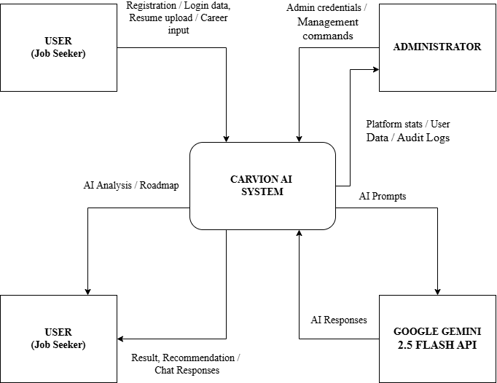

Figure: DFD Level 0 - Context Diagram

The Level 0 Data Flow Diagram (Context Diagram) represents the Carvion AI platform as a single process and illustrates its interaction with external entities. It provides a high-level view of the entire system without showing internal processes or data stores. The purpose of the context diagram is to define the system boundaries and identify the flow of information between the system and its external users or services.
In the Carvion AI platform, the primary external entities include the User, Administrator, and the Google Gemini 2.5 Flash API. Users interact with the system by registering, logging in, uploading resumes, requesting career roadmaps, participating in mock interviews, searching for jobs and learning resources, and communicating with the AI chatbot. Administrators manage user accounts, monitor system activities, generate reports, and maintain the platform through the administration module. The system communicates with the Google Gemini 2.5 Flash API to perform AI-based tasks such as resume analysis, ATS score generation, career roadmap creation, interview evaluation, chatbot assistance, and personalised recommendations.
The Level 0 Context Diagram provides an overall understanding of how data enters and leaves the Carvion AI platform before examining the detailed internal processes in the subsequent DFD levels.

LEVEL 1 – MAIN SYSTEM PROCESSES

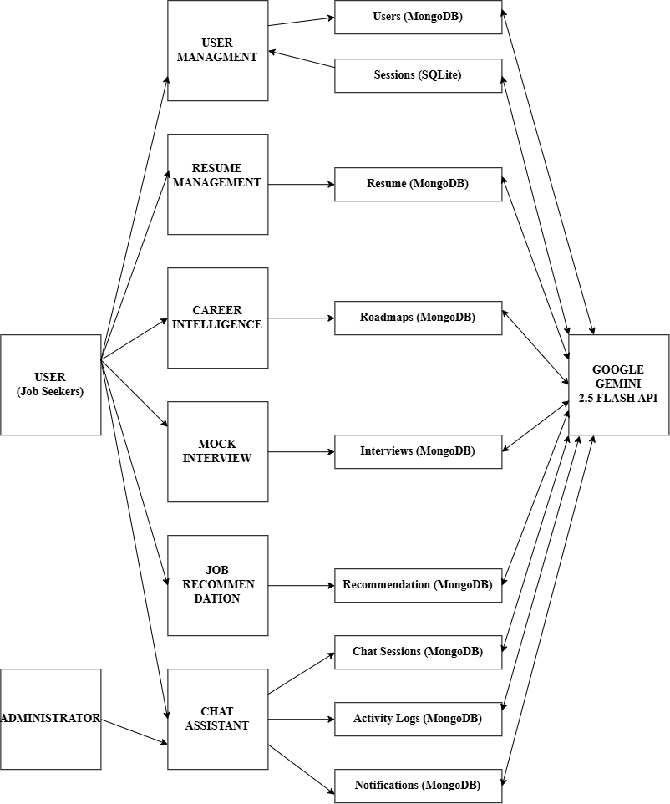

Figure: DFD Level 1 - Main System Processes
The Level 1 Data Flow Diagram (DFD) expands the Level 0 Context Diagram by dividing the Carvion AI platform into its major functional processes. It illustrates how data flows between different system modules, data stores, and external entities. This level provides a detailed view of the core functionalities while showing how information is processed and stored within the system.

The major processes included in the Level 1 DFD are:
- User Authentication and Account Management

Handles user registration, login, profile management, role-based access control, and secure authentication.
- Resume Management
Manages resume upload, document parsing, ATS score generation, resume analysis, and storage of resume information.
- Career Roadmap Generation
Generates personalized career roadmaps based on the user's skills, target job role, and AI analysis.
- Mock Interview and AI Chatbot
Conducts AI-based mock interviews, evaluates user responses, provides interview feedback, and offers career guidance through the chatbot.
- Job and Learning Recommendation
Recommends suitable job opportunities and learning resources based on the user's profile, skills, and identified skill gaps.
- Administration Module
Enables administrators to manage user accounts, monitor platform activities, view reports, manage notifications, and maintain the overall system.
The Level 1 DFD also includes the primary data stores, such as MongoDB, which stores user profiles, resumes, AI-generated roadmaps, interview sessions, recommendations, and chatbot data, and SQLite, which stores administrator information, authentication data, and other system-related records. The diagram also shows the interaction with the Google Gemini 2.5 Flash API, which performs AI-based operations including resume analysis, career roadmap generation, interview evaluation, chatbot responses, and recommendation generation.

The Level 1 Data Flow Diagram provides a clear understanding of how the major functional modules interact with each other and how data flows through the Carvion AI platform to perform its core operations.

LEVEL 2 – PROCESS DECOMPOSITION (RESUME MANAGEMENT)
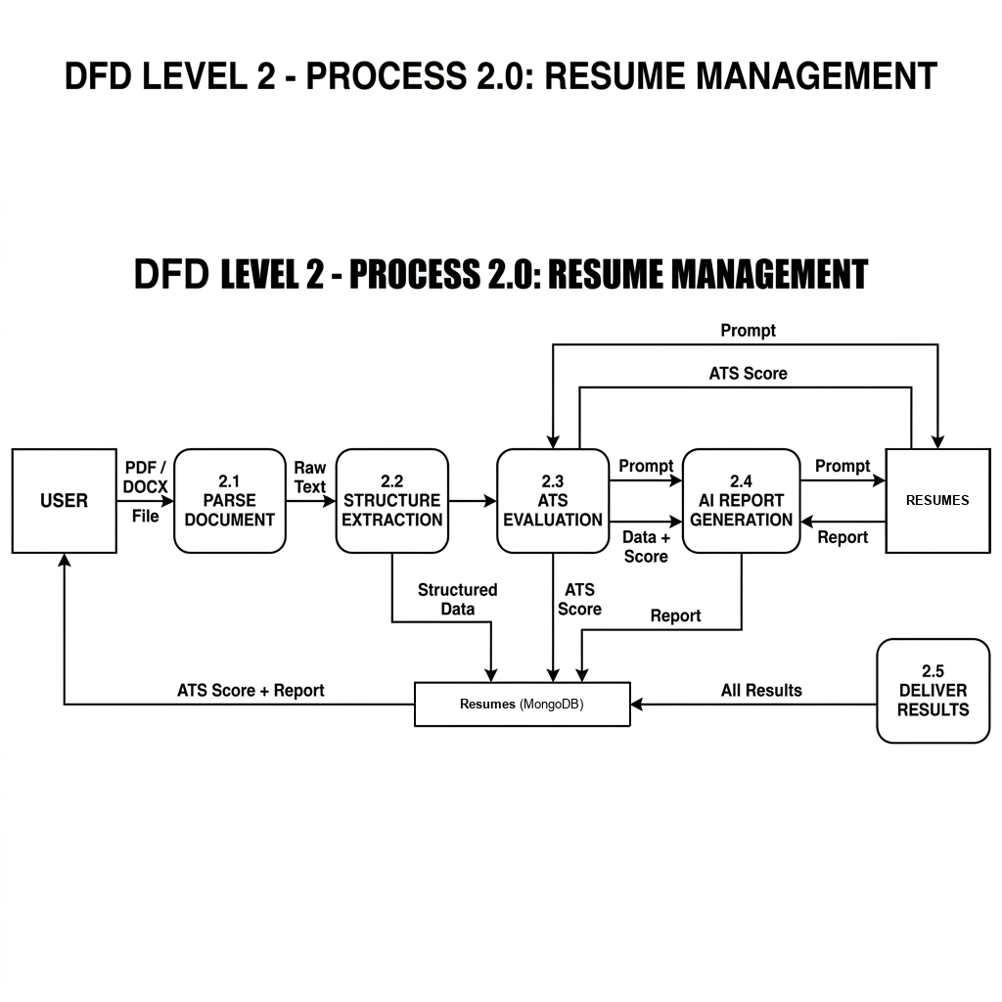
Figure: DFD Level 2 - Resume Management

The Level 2 Data Flow Diagram (DFD) provides a detailed view of the Resume Management process by decomposing Process 2.0 into its internal sub-processes. It illustrates how a resume is uploaded, processed, analyzed, stored, and made available to the user. This level helps in understanding the sequence of operations involved in resume management and the flow of data between the user, system modules, database, and the AI service.

The Resume Management process consists of the following sub-processes:
- Resume Upload

The user uploads a resume in PDF or DOCX format. The system validates the file format and securely stores the uploaded document.

- Resume Parsing

The uploaded resume is processed using PyMuPDF and python-docx to extract structured information such as personal details, education, work experience, technical skills, projects, and certifications.

- AI Resume Analysis

The extracted information is sent to the Google Gemini 2.5 Flash API for resume evaluation. The AI analyses the resume, generates an ATS compatibility score, identifies missing skills, and provides recommendations for improvement.

- Data Storage

The original resume, extracted information, ATS score, and AI-generated analysis are stored in the MongoDB database for future access.

- Resume Management

The user can view, update, download, or delete previously uploaded resumes and access the corresponding analysis reports whenever required.
The Level 2 DFD clearly illustrates the detailed workflow of the Resume Management module and shows how data moves between the user, processing components, AI service, and database to provide accurate resume analysis and management within the Carvion AI platform.

LEVEL 3 — SUB-PROCESS DETAIL

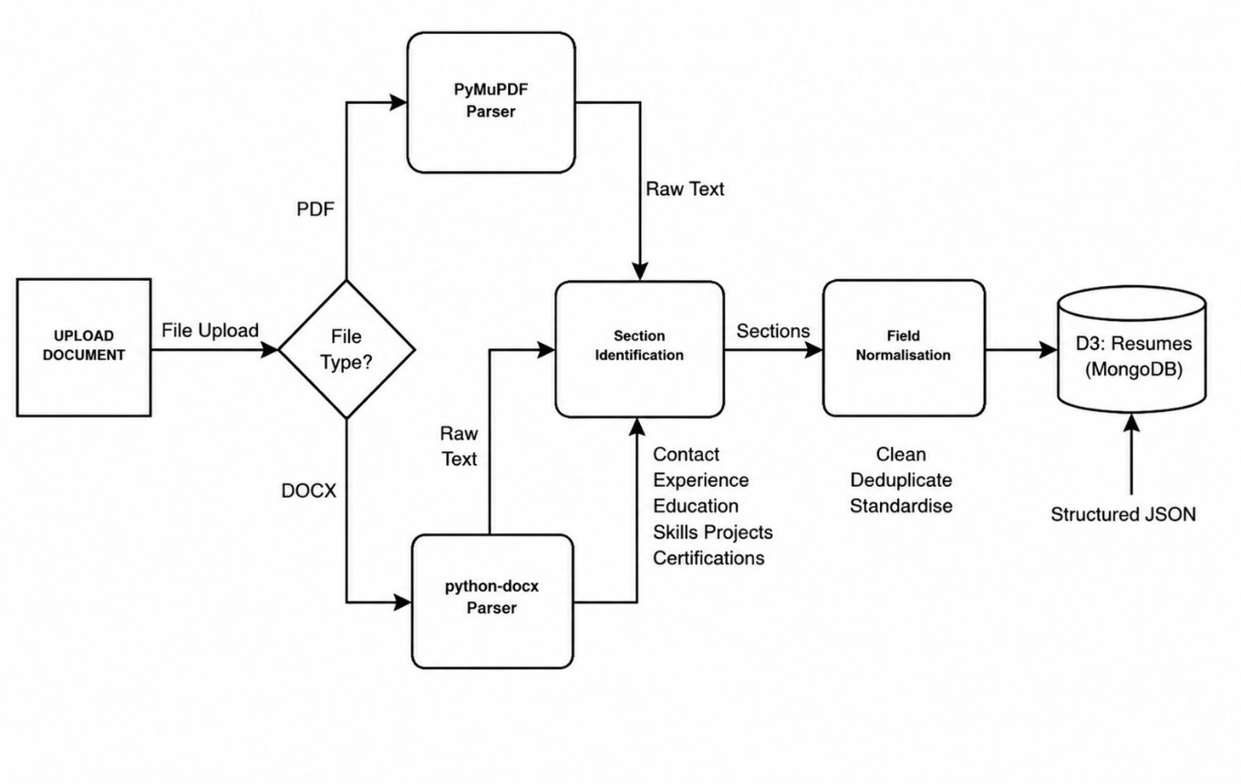
Figure: DFD Level 3 - Document Parsing
The Level 3 Data Flow Diagram (DFD) presents the most detailed view of the Document Parsing and Information Extraction process by further decomposing Processes 2.1 (Resume Upload) and 2.2 (Resume Parsing) into individual processing steps. It illustrates how the uploaded resume is validated, processed, analysed, and converted into structured information before being stored in the database and used for AI-based analysis.

The document parsing and extraction process consists of the following sub-processes:

- File Upload and Validation

The user uploads a resume in PDF or DOCX format. The system verifies the file format and validates the uploaded document before processing.

- Text Extraction

The system extracts the textual content from the uploaded resume using PyMuPDF for PDF files and python-docx for DOCX files.

- Information Extraction

The extracted text is analysed to identify important information such as personal details, educational qualifications, work experience, technical skills, projects, certifications, and other relevant resume sections.

- AI Processing

The structured resume information is sent to the Google Gemini 2.5 Flash API for detailed analysis. The AI generates an ATS compatibility score, identifies skill gaps, provides resume improvement suggestions, and prepares additional career-related insights.

- Data Storage

The original resume, extracted information, and AI-generated analysis are securely stored in the MongoDB database, allowing users to access their resume history and reports at any time.

- Result Generation

The processed information, ATS score, extracted skills, and improvement recommendations are returned to the user through the Resume Management module for viewing and further actions.

NOTATIONS USED

NAME | NOTATION | DESCRIPTION
Process |  | A process transforms incoming dataflow into outgoing dataflow. A process is shown by named circles.
Data flow |  | Dataflows are pipelines through which packet of information flow. Label the arrows with the name of the data that moves through it.
External entry |  | External Entities are objects outside the system, with which the system communicates. External Entities are the sources and the destinations of the system’s input and output.

ENTITY RELATIONSHIP DIAGRAM

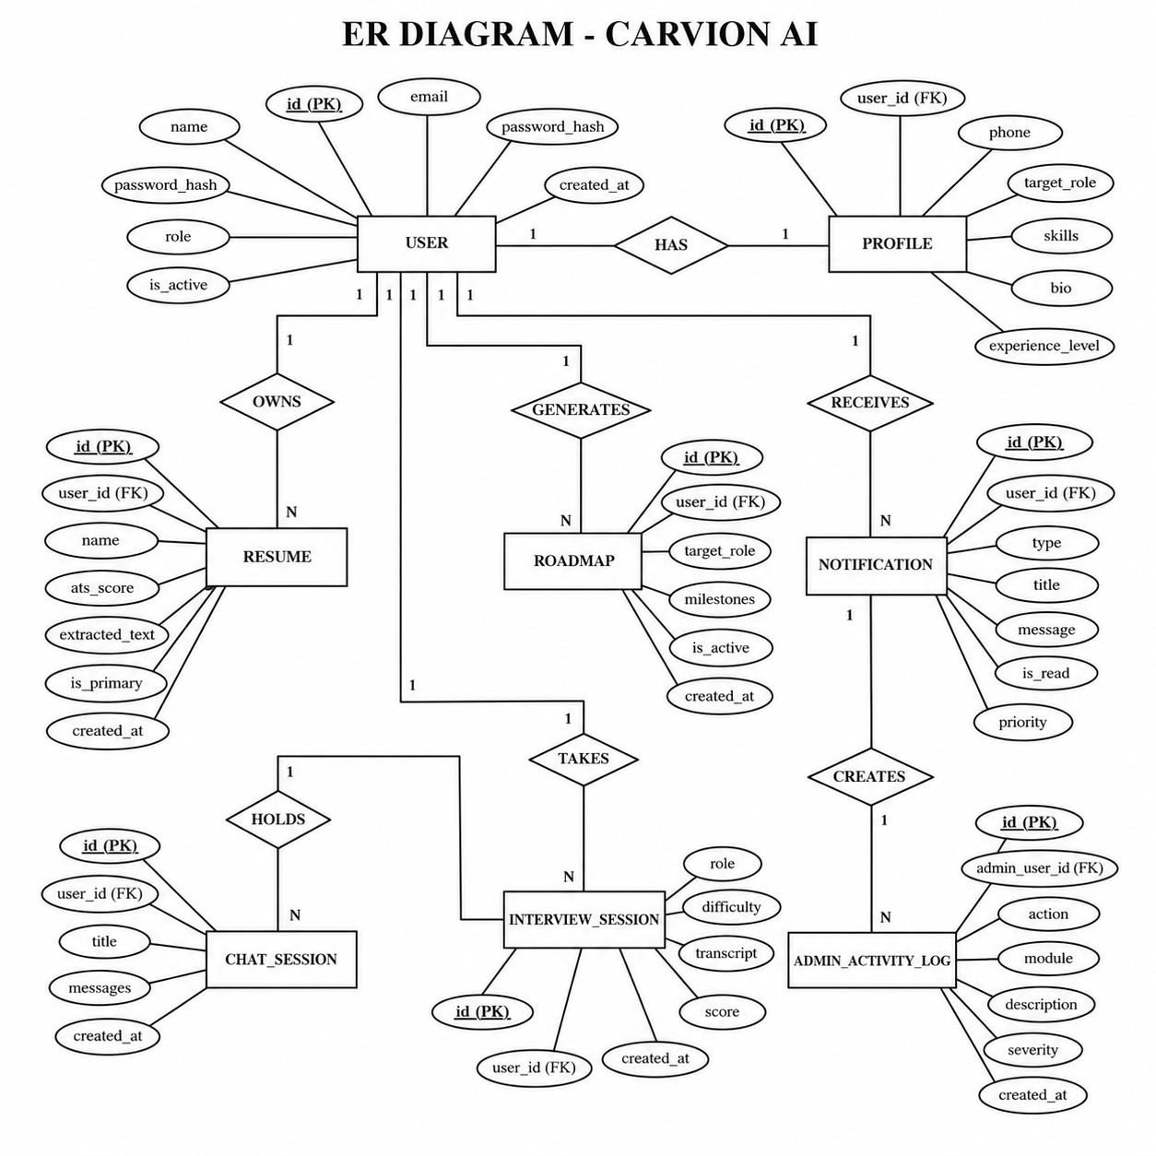
Figure: ER Diagram - Carvion AI

Entity Relationship (ER) Diagram represents the logical database design of the Carvion AI platform. It illustrates the major entities, their attributes, primary keys, foreign keys, and the relationships between them. The ER Diagram provides a clear understanding of how data is organized, stored, and related within the system.

The Carvion AI database consists of several interconnected entities, including User, Administrator, Resume, Career Roadmap, Mock Interview, Job Recommendation, Learning Recommendation, Chatbot Conversation, Notification, Contact Message, and Activity Log. Each entity stores information required for a specific module of the application, while relationships between entities ensure efficient data management and maintain data integrity.

The ER Diagram provides the foundation for database design by defining how entities are connected and how information flows between different modules. It also helps ensure consistency, reduce data redundancy, and maintain the integrity of the database throughout the application.

NAME | NOTATION | DESCRIPTION
Attribute |  | The properties of entity can be attribute. It is represented by ellipse.
Relationship |  | Whenever an attribute of one entity refers to another entity, some relations exists.
Entity |  | It may be an object with physical existence or conceptual existence.
Link |  | Lines link attribute to entity sets an entity set relation
Key Attribute |  | Primary Key: It signifies unique and non null values.
NOTATIONS USED

FACILITIES REQUIRED FOR PROPOSED WORK
The development and testing of the Carvion AI platform require the following hardware and software resources.

HARDWARE REQUIREMENTS
- Processor

Intel Core i5 / AMD Ryzen 5 processor or higher.

- Memory

Minimum 8 GB RAM (16 GB recommended).

- Storage

Minimum 256 GB SSD with sufficient free space.

- Network

Stable high-speed Internet connection for API access and software installation.

SOFTWARE REQUIREMENTS
- Operating System

Windows 10/11, macOS, or Linux.

- Integrated Development Environment (IDE)

Visual Studio Code or PyCharm.

- Programming Languages

Python 3.11+, JavaScript (Node.js 18+), HTML5, and CSS3.

- Frameworks

React.js, Vite, Django REST Framework (DRF), and Simple JWT.

- Database

MongoDB and SQLite.

- Libraries & SDKs

Google Gemini API, MongoEngine, PyMuPDF, python-docx, Axios, and TanStack Query (React Query).

PLAN OF WORK
The development of Carvion AI is planned over a period of 4 months, with each month focusing on a specific phase of the project.

MONTH | PHASE / ACTIVITIES | DELIVERABLES
Month 1 | Requirement analysis, literature review, feasibility study, system design, and database design (ERD & DFD). | Requirements document, system design, ERD, DFD, and UI design.
Month 2 | Backend development, user authentication, database integration, and resume parsing module implementation. | Working backend APIs, authentication module, database setup, and resume parser.
Month 3 | Frontend development, AI integration, resume analysis, ATS scoring, job recommendations, learning module, chatbot, and mock interview module. | Functional user interface and integrated AI modules.
Month 4 | Admin module development, system integration, testing, debugging, documentation, and project completion. | Complete working system, test reports, project documentation, and final project submission.

BIBLIOGRAPHY

OFFICIAL DOCUMENTATION
- Google DeepMind. (2024). Gemini API Documentation — Google AI for Developers. Google LLC. Retrieved from https://ai.google.dev/gemini-api/docs

- Django Software Foundation. (2024). Django Documentation — Version 4.x. Retrieved from https://docs.djangoproject.com/en/4.2/

- Tom Christie. (2024). Django REST Framework Documentation. Retrieved from https://www.django-rest-framework.org/

- Jazzband. (2024). Django REST Framework Simple JWT Documentation. Retrieved from https://django-rest-framework-simplejwt.readthedocs.io/

- MongoEngine Contributors. (2024). MongoEngine — Python Document-Object Mapper for MongoDB. Retrieved from https://docs.mongoengine.org/

- MongoDB, Inc. (2024). MongoDB Manual — Version 7.0. Retrieved from https://www.mongodb.com/docs/manual/

- Meta Open Source. (2024). React — The Library for Web and Native User Interfaces. Retrieved from https://react.dev/

BOOKS AND REFERENCE MATERIALS
- Flanagan, D. (2020). JavaScript: The Definitive Guide (7th ed.). O'Reilly Media.

- Lutz, M. (2013). Learning Python (5th ed.). O'Reilly Media.

- Chodorow, K. (2013). MongoDB: The Definitive Guide (2nd ed.). O'Reilly Media.

- Fowler, M. (2002). Patterns of Enterprise Application Architecture. Addison-Wesley Professional.

- Gamma, E., Helm, R., Johnson, R., & Vlissides, J. (1994). Design Patterns: Elements of Reusable Object-Oriented Software. Addison-Wesley Professional.

RESEARCH PAPERS
- Vaswani, A., Shazeer, N., Parmar, N., Uszkoreit, J., Jones, L., Gomez, A. N., Kaiser, L., & Polosukhin, I. (2017). Attention Is All You Need. Advances in Neural Information Processing Systems, 30. Retrieved from https://arxiv.org/abs/1706.03762

- Brown, T. B., et al. (2020). Language Models are Few-Shot Learners. arXiv preprint arXiv:2005.14165. Retrieved from https://arxiv.org/abs/2005.14165

- OpenAI. (2023). GPT-4 Technical Report. arXiv preprint arXiv:2303.08774. Retrieved from https://arxiv.org/abs/2303.08774

